JOHN HANCOCK - PROJECT COEUS FRONT END ASSEMBLY 2
Deployment Guide

Revision History
Author | Revision Number | Date
veshu | 1.0 | 5/29/2016

Deployment Instructions 3
1. Organization of Submission 3
2. Application Setup 3
3. REST API Server Setup 3
4. Configuration 3
5. Deployment 3
6. Verifications 3
6.1. Login Page (with admin) 5
6.2. Home Page 5
6.3. Add Assessment Page 7
6.4. Assessments list Pages 7
6.5. Assessment Detail Page 8
6.6. Assessment Edit Page 13
6.7. Miscellaneous Verification 14
7. Resource Contact List 15

Deployment Instructions

Organization of Submission

Directory / File Name | Description
\Docs\ | The deployment guide. Including deployment guide from assembly 1 in “assembly1” folder.
\Src\Server | The REST server source code.
\Src\App | The frontend application source code.
\TestFiles | The database scripts to load test data.

Application Setup
Please check previous deploy guide
Docs\assembly1\Deployment Guide.doc

REST API Server Setup
Please check previous deploy guide
Src\Server\docs\Deployment Guide.doc

Configuration
Please check file Src\App\js\config.js.
Usually you only need to change REST_SERVICE_BASE_URL.

property name | Description | example value
REST_SERVICE_BASE_URL | the base URL of rest API | http://localhost
DATE_FORMAT | The date format to use on the application | ' MMM dd, yyyy' See here for more options
KPISLA_ASSESSMENT_CATEGORY_ID | The category id for KPI/SLA Assessment | See the config.js. The value should be taken from category table
FUNCTIONAL_ASSESSMENT_CATEGORY_ID | The category id for Functional area process Assessment | See the config.js. The value should be taken from category table
CORP_DIV_TRAINING_ASSESSMENT_CATEGORY_ID | The category id for Corporate & Divisional Training Assessment | See the config.js. The value should be taken from category table
USER_DEFINED_KEY_CONTROLS_MATURITY_ID | The id of key controls maturity for which user comment is required. | See the conifig.js. The value should be taken from [LikelihoodOfOccurrence] table
USER_DEFINED_KEY_LIKELIHOOD_OF_OCCURRENCE_ID | The id of likelihood of occurrence for which user comment is required. | See the conifig.js. The value should be taken from [KeyControlsMaturity] table
USER_DEFINED_TESTING_FREQUENCY_ID | The id of testing frequency for which user comment is required. | See the conifig.js. The value should be taken from [TestingFrequency] table
DEFAULT_PAGE_SIZE | The default page size in list table. This will be applied to all tables. | 2
MAXIMUM_ALLOWED_FUNCTION_CHANGES | The maximum number of function changes allowed while edit/add assessment | 20
NOTE:
- Other properties in config file are moreover constants, used in views. So, you don’t need to configure them unless modifying code.

Deployment
Please check previous deploy guide
Docs\assembly1\Deployment Guide.doc

Verifications
- You need to have at least 5 user accounts who can login to the application:
- See Src\Server\docs\Deployment Guide.doc to create the user on AD.
Note: While creating user the business unit should be from this table otherwise user will not be able to login
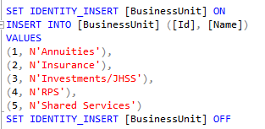
Now, create following user

Username | Role | Purpose
Any | Owner | To check with owner user
Any | BUFunctionalApprover | To check with BUFunctionalApprover user
Any | BURiskManagementApprover | To check with BURiskManagementApprover user role
Any | DivisionalRiskManagementApprover | To check with DivisionalRiskManagementApprover user role
Any | Admin | To check with admin role. To verify that admin is not allowed to login to the application

Once, the above user is created you have to update the TestFiles\TestData.sql script with username you have created. The other username which is not commented as required are only used to show in dropdown of department head/functional owner. So if you don’t need to verify from other account of same role you don’t need to update. Make sure you don’t choose those values while creating or update assessment.
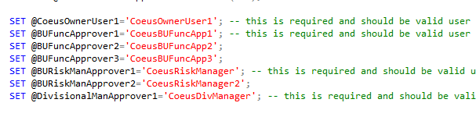
- I have hosted on port 8098, so my URL is http://localhost:8098/
- Insert test data on database by running TestFiles\TestData.sql on your database
- Permissions are as:
- All users can login the application using username and password.
- The owner user can only create assessment.
- The admin cannot login to the application.
- Owner can see all assessments created by him/her only
- BUFunctionalApprover can’t see draft and rejected assessments and assessments in which he is not department head/functional owner.
- BURiskManagementApprover can’t see draft, rejected and ‘Awaiting BU Functional Approval’. Also user’s business unit must match to the business unit of assessment to be able to view the assessment.
- DivisionalRiskManagementApprover can only see approved or ‘Awaiting Division Risk Management Approval’ assessments

- Now browse the application and verify

Login Page (with admin)
- Go to http://localhost:8098/
- Try to login with admin user, you should see following error
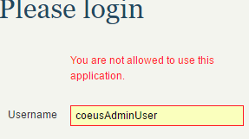

Home Page
- Login with Owner user credentials. You should see home page as
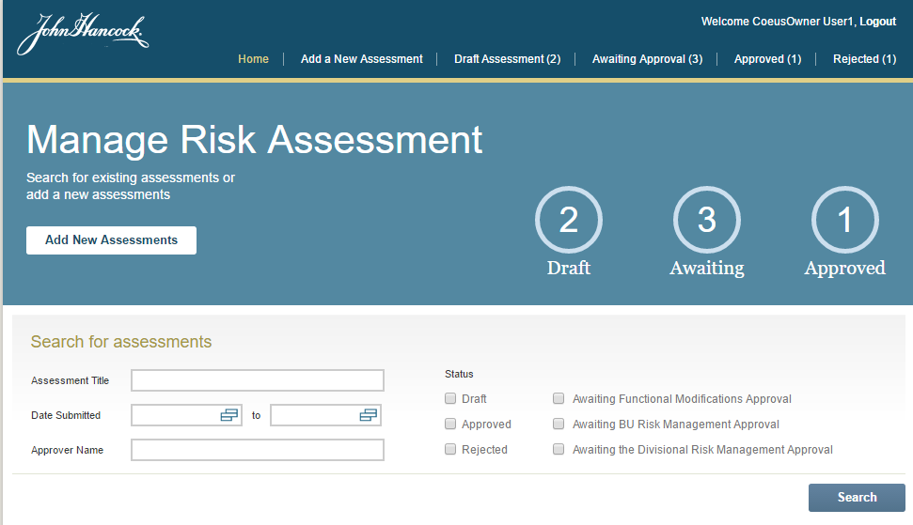
- Click the search button, to get the assessments
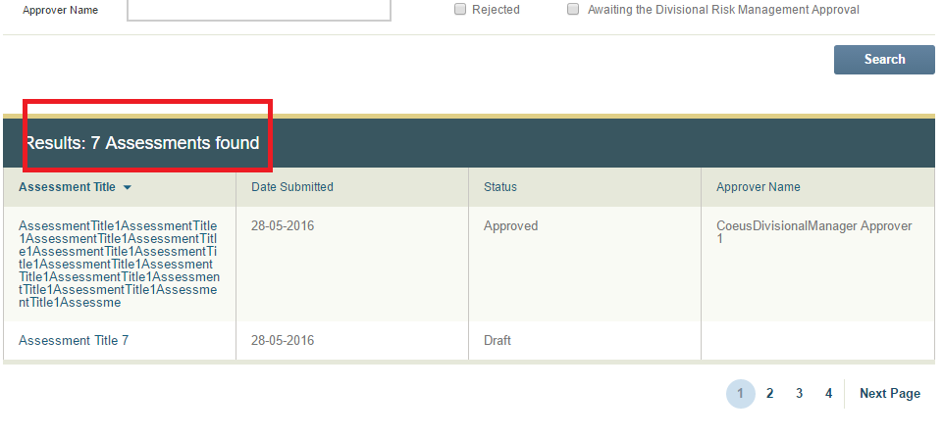
  - Verify the count of assessments
  - Verify the sorting(Sorting from User name is not available)
  - Verify the paging. To see more pages, please update the “DEFAULT_PAGE_SIZE” in Src\App\js\config.js
  - The maximum allowed length in text box is 2000. Otherwise with large text the API can’t handle the request as sent over query string.
  - Click on title of assessment to open detail page
  - When there is only one in search result.
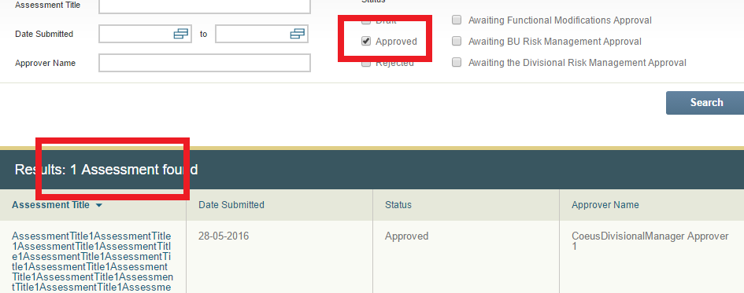
- Similarly, login with approver user. You should see home page as
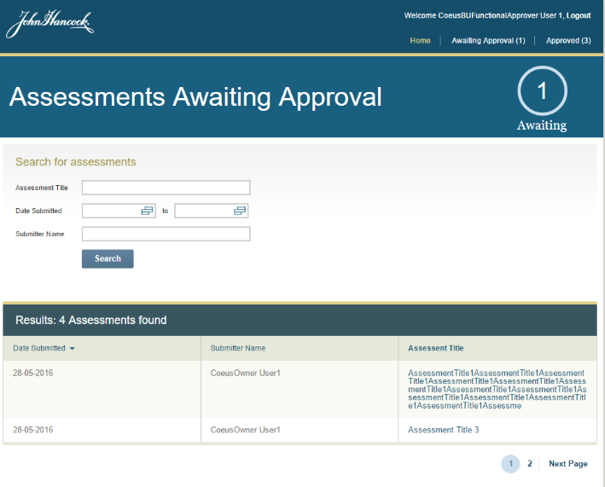
- Verify similar to owner user. Only difference is there is no filter by status.

Add Assessment Page
- Please check verification steps from previous assembly deployment guide. The only change made is now assessment title is required while saving as draft.

Assessments list Pages
- Login to the application with owner user(You can verify all link)
- Click on “Draft Assessment” link from menu, the list page will load as
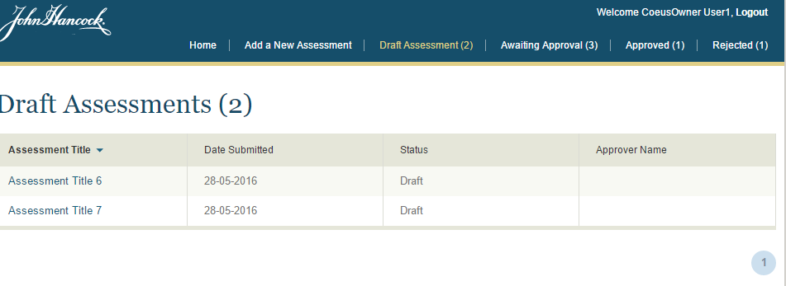
- Similarly, verify other links (Awaiting Approval, Approved, Rejected)
- Now, login with different approver and verify the number of assessments and their status. E.g. with Risk Manager you should see following in awaiting approval
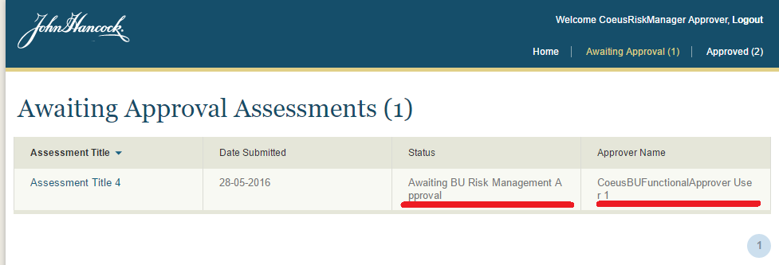

- Click the assessment title to go to detail page.

Assessment Detail Page
- Login with owner user(you will be able to view detail page in all status)
- Draft assessment detail.
  - Open assessment in draft status from home search result or from draft assessment list page. You will see following page
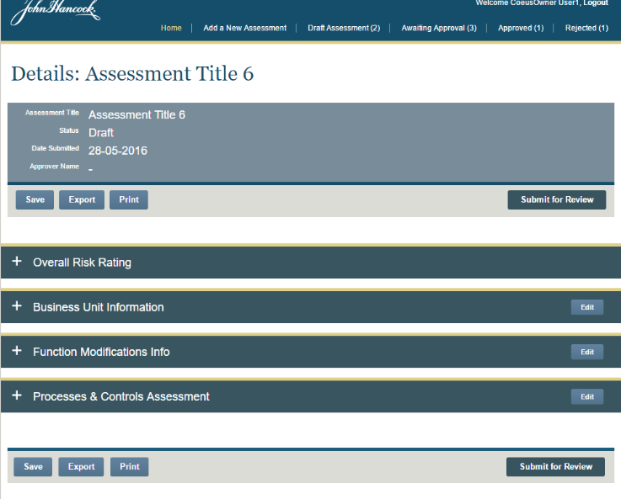
  - Verify save button. (There is only one field here in “Overall Risk Rating” section)
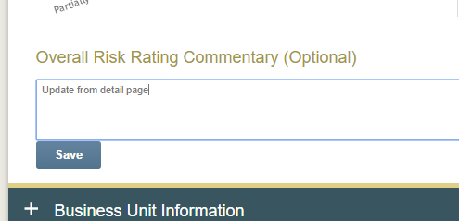
  - Verify Export, Print and submit for review
  - For the detail of this page please refer to verification of 4 tab of add assessment from previous assembly
  - The click on edit button, you will be redirected to edit page. It is very similar to add assessment page with prepopulated detail.

- Awaiting Functional Modifications Approval Assessment detail
  - In this status owner can export and print only.

  - From approver view the page will look like
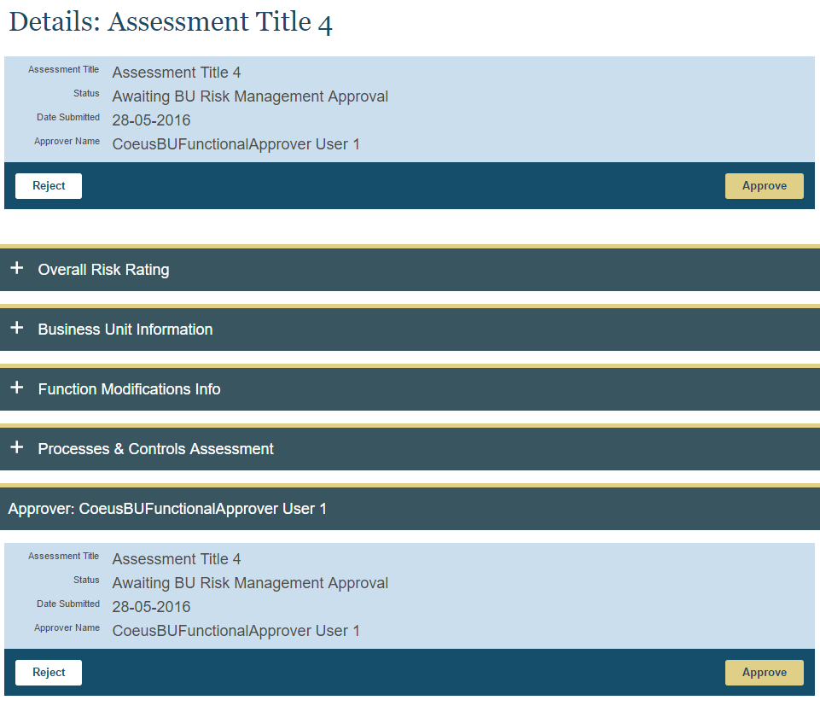

Click on Reject button, it will ask for reason for prompt, which is required.
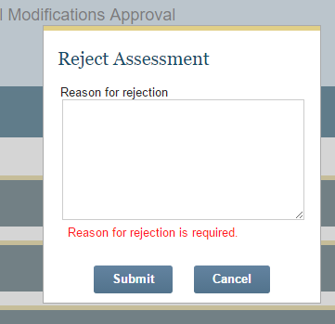

- For other awaiting approval status the detail page will not have the link for edit/save.
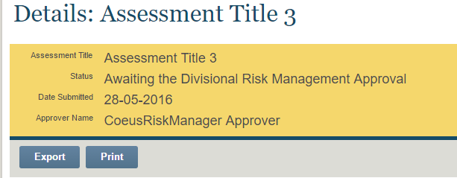

While for approver the view will be same as previous approver.

- Approved Assessment detail Page
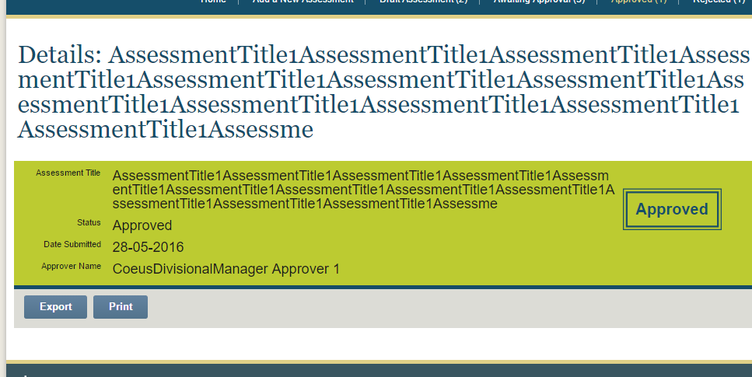
- Rejected assessment detail page
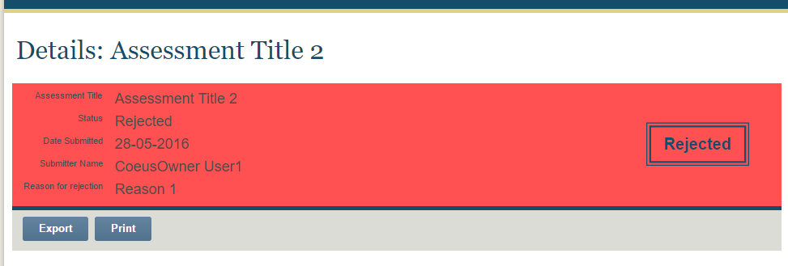

Assessment Edit Page
- Login with owner user
- Open a draft assessment page from search result in home or draft assessment menu and click any edit link from the detail page, you will be redirected to respective tab of edit page.
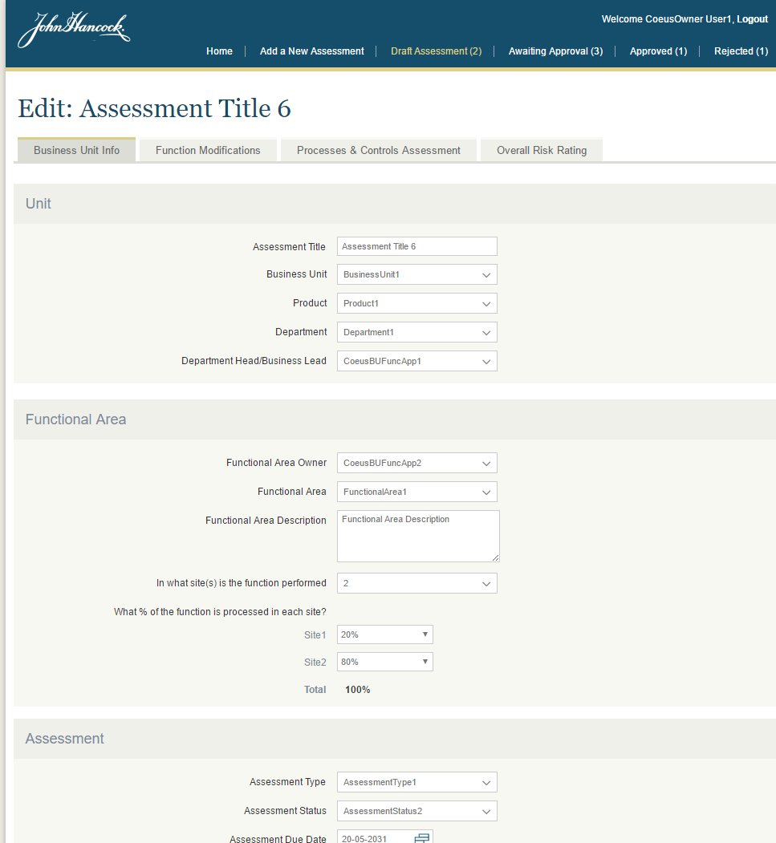
- This page is very similar to add assessment page, so please refer to verification section of deployment guide from assembly 1.

Miscellaneous Verification
- Verify approver can’t see the detail of draft or rejected assessment by entering the different id in URL. E.g. login with approver and enter http://localhost:8098/#/assessmentDetails/6 in URL. It will show the error message as 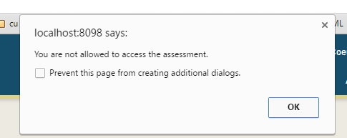
Click ok and you will be redirected to the previous page.
- Verify exported file. The fix includes the test comment reason for not testing in tested column of assessments
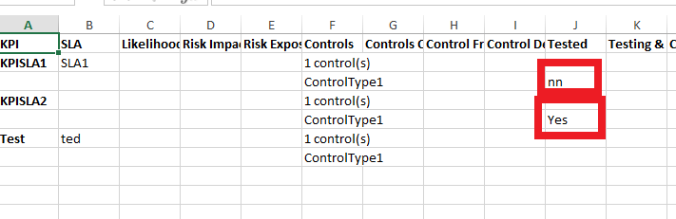
- Verify active menu while refreshing assessment detail page and edit page. The last menu should be highlighted

Resource Contact List

Name | Resource Email

